Cranborne Chase
Area of Outstanding Natural Beauty

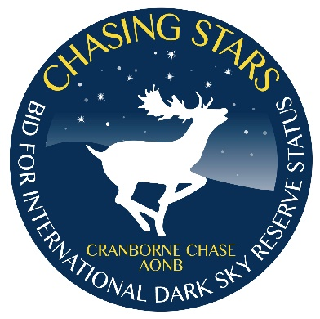 | Dark Night Skies:  Achieving Community Benefits  Working in Harmony in an AONB  9:30 coffee; 10am start – 4:15 finish  Dinton Village Hall, SP3 5EB

20th MARCH 2018 BOOKING FORM

Name: ……………………………………………………………………......................

Organisation: …………………………………………………………………….

Role / Position: …………………………………………………………………….

Address: …………………………………………………………………….

Telephone: ……………………………E-mail……………………………………….

There is a seminar fee of £48 (£40 + VAT @ £8)
with free tea, coffee and lunch provided.
You can pay by
- cheque for £48 made payable to Wiltshire Council, or
- provide an purchase order number and contact name, or
- for late bookings only, pay cash on the day

Purchase Order Number and name and address for sending invoice:

……………………………………………………………………………………………
If you have any special dietary, access or other requirements, please let us know.
We can provide a CPD certificate; please tick if you require one
Please return your completed booking form by 5pm Monday 12th March
By e-mail to: shirleymerrick@cranbornechase.org.uk or

By post to: Cranborne Chase Area of Outstanding Natural Beauty,
Shears Building, Stone Lane Industrial Estate, Wimborne, BH21 1HB

Cancellations accepted up to 5pm on 9th March but refunds will incur a £10 administration charge.
No refunds available after this time. Bookings are transferable.

